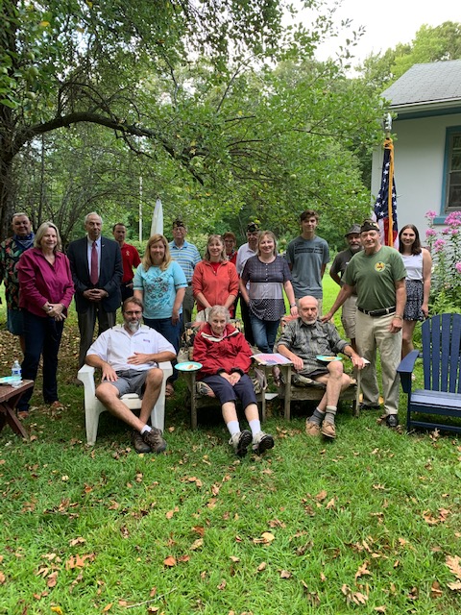

VFW Post 10689 Ellington/Tolland was part of a ceremony (invited by the family and Town Officials from Ellington) to honor their father Francis Degray a proud WW II veteran.  Mr. Degray stood up and spoke to us which his family never expected. I am pictured with the veteran and Quartermaster Bruce Warkentin joined.